***Classic alarm clock***

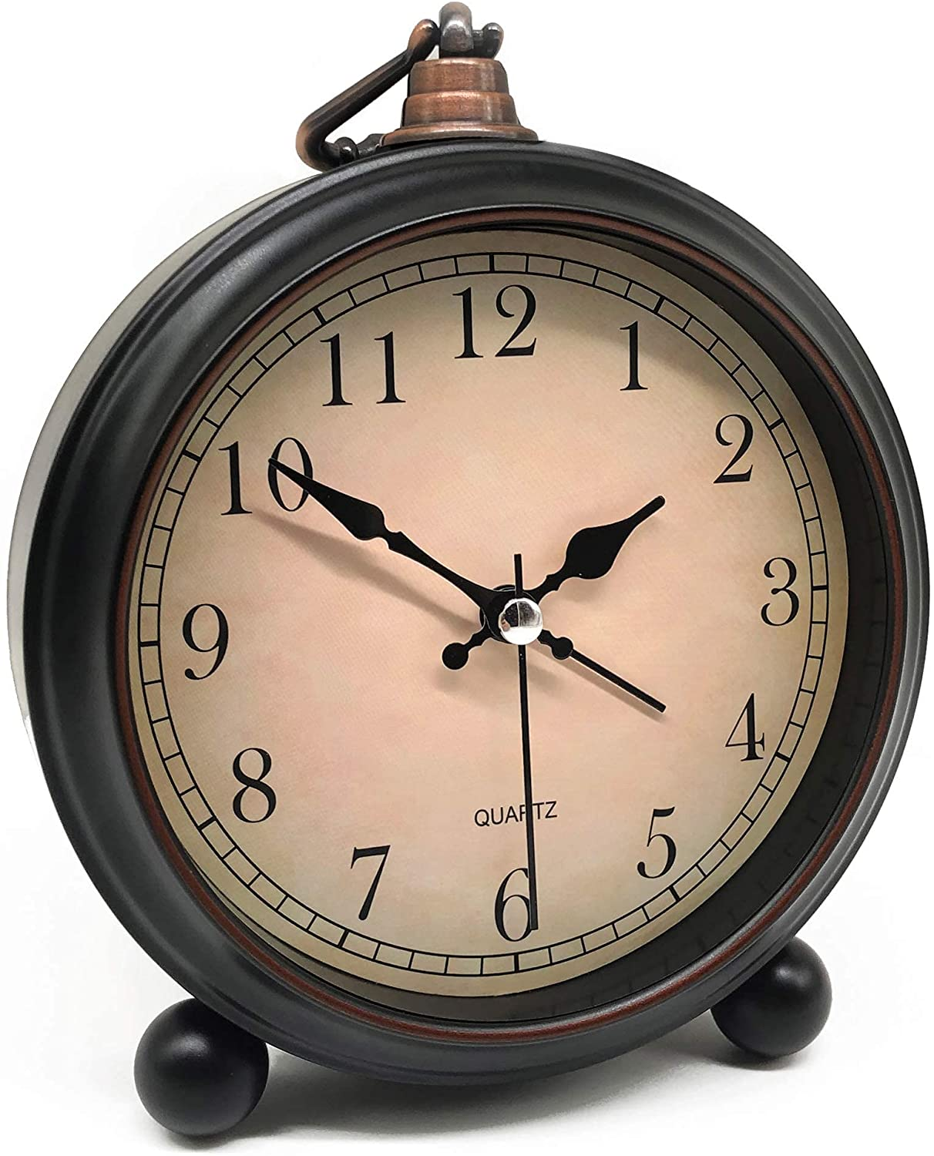

*lassic alarm clock made of metal material. Has functions to see the time, alarm, LED light to see the time in the night. The alarm clock is suitable as a birthday gift, a gift for a girlfriend, etc*